A Guide to UK Universities
The United Kingdom is home to some of the world’s most prestigious universities, renowned for their academic excellence, research output and rich cultural heritage. This guide is tailored for international students and their families—particularly those based in Asia—who are considering pursuing a degree in Britain.

English Language Requirements
To gain admission to foundation, undergraduate or postgraduate programmes at UK universities and obtain a student visa, applicants must demonstrate their English proficiency. Universities accept a range of tests—including IELTS, TOEFL iBT, Pearson PTE, Trinity ISE, LanguageCert and Cambridge English—and set minimum overall and component scores. While each institution and course may have unique criteria, the following table summarises common benchmarks across different levels of study:
Study Level | Typical IELTS (overall) | Typical TOEFL iBT | Notes
Foundation pathway | 5.5 | ≈72 | IELTS with no band below 5.5; alternative tests accepted
Undergraduate | 6.0 | ≈79 | Minimum 6.0 with no component below 5.5; some universities require 6.5 or higher
Postgraduate | 6.5 – 7.0 | ≈91 | Most master’s courses need 6.5–7.0 overall with minimum 6.0 in each element; high-demand disciplines require 7.0
Research degrees (PhD) | 6.5 – 7.0+ | ≈91+ | Doctoral programmes typically ask for 6.5–7.0 with higher writing component
Figure 1: Typical IELTS requirements for foundation, undergraduate, postgraduate taught and PhD programmes (approximate values for illustration). Actual scores vary by university.
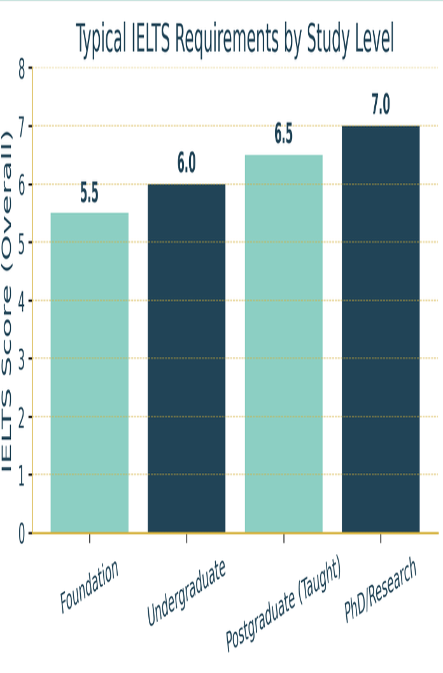
Table 1: Indicative English language requirements for study levels at UK universities.
These figures serve as a baseline—always confirm exact requirements with your chosen institution.

Why Study at a UK University?
The UK remains one of the most popular destinations for international students thanks to its combination of academic rigour, cultural diversity and career opportunities. Key reasons include:
- World-class education: UK universities are globally renowned for teaching and research excellence. Many institutions consistently rank among the world’s top universities and foster critical thinking, independent study and innovation.
- Global recognition and employability: A UK degree is highly valued internationally. Graduates report progressing further in their careers, being promoted faster and earning more thanks to their British education.
- Shorter and cost-effective degrees : Bachelor’s degrees usually take three years (four in Scotland), while many master’s programmes can be completed in one year, saving time and tuition compared with other countries.
- Industry links and work experience: Universities maintain close ties with employers and offer internships, placements and sandwich years that give students real-world experience.
- Cultural diversity and networking: With students from across the globe, UK campuses are vibrant communities that encourage cross-cultural friendships and global networking.
- Graduate Route visa: After completing an undergraduate or master’s degree, international students can stay in the UK for two years (three for PhDs) to work or search for jobs under the Graduate Route.
Together, these factors make a UK university education a strategic investment in your academic and professional future.

Understanding Degree Structures
The UK higher education system offers a variety of pathways designed to suit different academic backgrounds and ambitions:
- Foundation programmes: These one-year courses prepare students who lack the academic or English prerequisites for direct entry to an undergraduate degree. They focus on subject knowledge, study skills and language development, leading to a range of degree options.
- Bachelor’s degrees: The most common undergraduate qualification, typically lasting three years (four in Scotland). Students may pursue single-subject degrees (BA, BSc, BEng) or combine subjects via joint honours programmes.
- Sandwich courses and placements: Many degrees offer a paid industrial placement or a year studying abroad, extending the programme by a year and giving students professional experience.
- Integrated master’s: These four-year programmes blend undergraduate and postgraduate study, culminating in a master’s qualification.
- Postgraduate degrees: One-year master’s programmes allow graduates to specialise in their field or pivot to a new discipline.
- Research degrees: PhDs and other doctoral programmes involve 3–4 years of original research and thesis preparation. They are ideal for students seeking an academic or research-focused career.

Options After Your Bachelor’s
Completing an undergraduate degree opens a wealth of possibilities. Many students continue with:
- Taught master’s programmes: One-year courses that develop advanced knowledge and professional skills in a specific subject. Many universities offer alumni discounts or scholarships for continuing students.
- Research or doctoral degrees: For those passionate about discovery, a PhD allows deep exploration of a topic over several years.
- Professional qualifications: Postgraduate certificates (e.g., PGCE for teaching) and MBAs provide targeted training for specific careers.
Alternatively, some graduates go straight into work, supported by the UK’s Graduate Route visa (see below).

Staying and Working in the UK
The UK recognises that international graduates offer valuable skills and perspectives. The Graduate Route visa allows students who have completed an undergraduate or master’s degree to remain in the UK for two years (three for PhD graduates) to work or look for work. This route is unsponsored, meaning you do not need a job offer to apply. During your studies, take advantage of university career services, attend employer fairs and network with alumni. The UK’s strong ties to global industries and its reputation for producing employable graduates mean there are opportunities across sectors. Graduates who secure a skilled job with an approved salary threshold can later switch to the Skilled Worker visa for longer-term employment.

Tuition Fees and Scholarships
Studying in the UK is considered good value for money compared with other English-speaking destinations. Undergraduate tuition fees for overseas students generally range from £11,400 to £38,000 per year, while master’s programmes cost £9,000 to £30,000. Because bachelor’s degrees are typically three years and many master’s courses last just one year, total tuition and living costs may be lower than in countries where programmes take longer.
Universities and external organisations offer numerous scholarships. Notable schemes include Chevening Scholarships, Commonwealth Scholarships and GREAT Scholarships, while individual universities may provide merit-based awards, subject-specific funding and alumni discounts. Early research and proactive applications increase your chances of securing financial support.

Finding a Job in the UK
UK universities boast dedicated career services that help students develop employability skills, build CVs and connect with employers. Make the most of internships, placements and part-time work during your studies, as these experiences often lead to full-time roles. International students can work part-time during term (usually up to 20 hours per week) and full-time outside term. Many companies actively recruit graduates from UK universities because of their ability to think critically and solve problems.
The UK’s multicultural environment also means graduates can build networks across continents.

Conclusion
A UK university education combines world-class teaching, internationally recognised qualifications and extensive opportunities for personal and professional growth. By understanding entry requirements, degree structures, financial considerations and post-study options, you can make an informed decision and maximise the benefits of your investment. For tailored advice on selecting courses, preparing applications and navigating visas, please contact Nova Scholars. Our London-based team is dedicated to helping high-achieving students unlock the full potential of a British education.

