Differences between UK and US universities

Introduction
Choosing where to attend university is a life-changing decision. For families relocating or sending their children overseas, the choice often comes down to two world-leading systems: the United Kingdom and the United States. Both offer prestigious institutions and global networks, yet they differ markedly in course structures, admissions, teaching styles, costs and campus life. This guide highlights the main distinctions to help you make an informed decision and to explain why the UK’s efficient, focused programmes often appeal to ambitious students seeking an early start to their careers.
Why this matters: Selecting the right university system influences not only the educational experience but also the cost, time to graduation and professional pathways available to your child. Understanding the contrasts between the UK and the US empowers you to align your child’s education with their ambitions and your family’s long-term goals.

Degree & course structure
Subject selection: In the UK, students choose their degree subject when they submit their university application and all of their classes relate to that subject. There is some flexibility to switch early in the degree, but the expectation is that you specialise from the start. This clear focus allows students to immerse themselves in a discipline from day one, building expertise and momentum. By contrast, US universities allow undergraduates to explore a broad liberal-arts curriculum before declaring a major at the end of the second year, meaning American students sample humanities, arts and science courses alongside their intended field and often take longer to settle on a path.
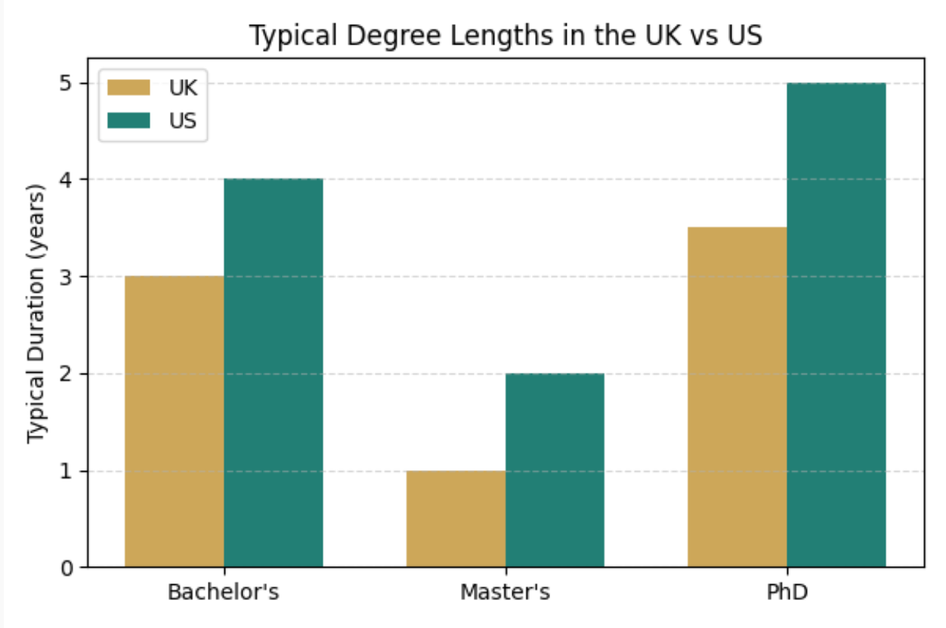
Degree length: Because UK degrees are more specialised, they are shorter. A bachelor’s degree typically takes three years in England, Wales and Northern Ireland (four in Scotland), master’s degrees usually last one year, and doctoral programmes run three-to-four years. Completing your degree sooner means you enter the workforce earlier and spend less on living expenses. In the US the broader curriculum extends the timeline: most bachelor’s degrees require four years, master’s degrees two years and doctorates five-plus years.
Flexibility & transferability: US students can change majors, add second majors or minors and even transfer between institutions relatively easily. While this flexibility appeals to undecided students, it can mean lost credits or extended study. Transfers are unusual in the UK; switching institutions often requires restarting the degree. Many families appreciate the structured and disciplined journey of a UK degree, which encourages commitment and timely completion. Moreover, professional degrees in medicine and law start at undergraduate level in the UK, allowing students to enter these fields immediately, whereas US students must first complete a bachelor’s degree.

Admissions & application process
Centralised vs individual applications: UK applications are submitted through UCAS, a centralised portal where students pay a single fee and can apply to up to five universities. One polished personal statement accompanies every UCAS application, and deadlines are uniform (earlier for Oxbridge, medicine and veterinary courses). This streamlined approach saves time and money and encourages applicants to focus on their best-fit courses. US universities either use the Common Application or their own forms; students pay separate fees for each institution and can apply to as many as they wish. Supplemental essays and custom questions are common, making the US process more complex and costly.
Selection criteria: UK admissions rely primarily on predicted or achieved grades and the relevance of the student’s chosen subject, in addition to references from teachers. Extracurriculars support the application but traditionally have played a smaller role. This emphasis on academic merit makes the process more transparent and easier to prepare for. US institutions adopt a holistic review, weighting essays, recommendations, leadership roles, athletics and community engagement alongside academic performance. Early decision or early action rounds, which bind or advantage applicants who apply earlier, are unique to the US admissions landscape and can add pressure to an already demanding process.
Number of institutions: The scale of choice differs dramatically: there are around 200 universities in the UK compared with over 4,000 colleges and universities in the US. While the US offers sheer volume—from public and private universities to liberal-arts colleges and specialised institutions—the UK’s more compact system makes it easier to compare options, and the majority of institutions are publicly funded with high academic standards.

Teaching & learning styles
Approach to learning: UK courses emphasise lectures, independent study and critical essays. Students receive a few “contact hours” per week and are expected to manage substantial self-directed reading. This autonomy cultivates maturity, discipline and research skills prized by employers. Assessments are weighted heavily towards end-of-year examinations and long essays, and degrees are classified as first-, upper-second-, lower-second- or third-class honours, providing clear benchmarks of achievement.
In the US, classes often combine lectures and discussion seminars. Continuous assessment—quizzes, problem sets, participation and midterms—contributes to the final grade. The result is expressed as a grade point average (GPA) on a 0–4 scale. Because students attend more classes and complete regular assignments, their weekly workload may be heavier.
Curriculum breadth: The British system’s early specialisation means that all modules relate to the chosen discipline. This laser focus suits students with clear goals, avoids unnecessary courses and allows them to build depth in their field more quickly. The American liberal-arts approach encourages exploration across humanities, social sciences and sciences before specialising. This flexibility can be attractive to students who are undecided or who wish to combine fields like economics and computer science, but it inevitably extends the time and expense of the degree.

Costs & funding
Tuition fees: International tuition fees in the UK vary by institution and subject but generally range between £10,000 and £30,000 per year. Recent surveys put the average around £22,200 (≈$28,095) for international undergraduates. Because degrees are shorter, the overall cost—including accommodation and living expenses—can be significantly lower than in the US.
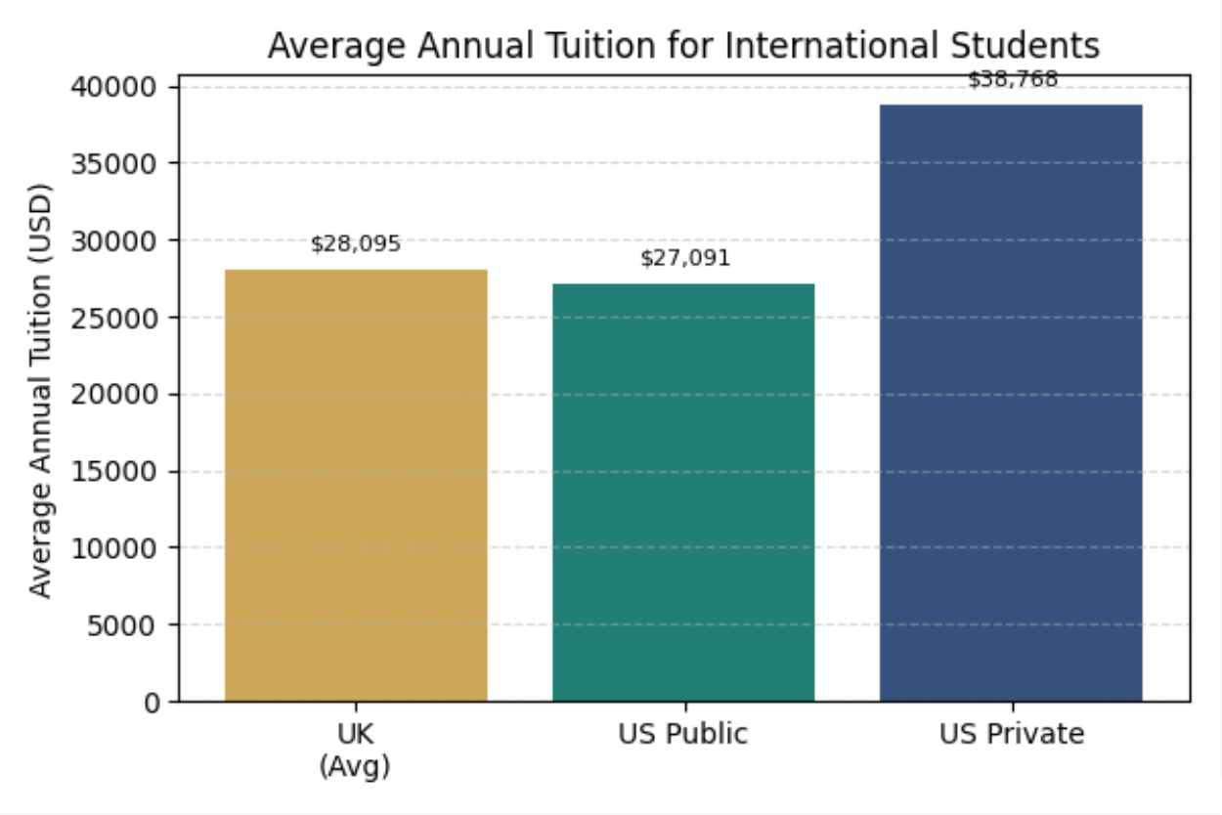
In the US, tuition fees depend on whether the university is public or private. International students at public universities pay $27,091 per year on average, while private universities charge about $38,768. Elite private institutions can exceed $55,000 per year.

Financial aid: Domestic students in the UK may borrow from the government’s Student Finance scheme, but this is unavailable to most international applicants. Scholarships exist, but they are competitive and generally smaller than their US counterparts. However, because tuition and living costs are lower, international families often find that they need less aid to make a UK education affordable. US universities, particularly private ones, offer merit-based and need-based scholarships and loans; however, these often require complex applications and can leave graduates with significant debt. Both countries permit part-time work on a student visa, subject to visa conditions.

Campus life & accommodation
Housing: First-year students in the US typically live in on-campus dormitories, sharing a bedroom with a roommate. In the UK, students usually have a private bedroom within a shared flat or hall of residence, and some universities offer self-contained studio apartments. The additional privacy and quiet offered by UK accommodation can make it easier to study and adjust to independent living.
Student societies & social culture: Both countries have vibrant clubs and societies, but Greek life (fraternities and sororities) is unique to US campuses. UK universities host a wide range of societies—from academic groups to sports clubs and volunteer organisations—without the exclusivity of the fraternity/sorority system. Sporting culture is a prominent part of US college identity, with large audiences and scholarships for athletes. British universities also offer sports, yet competitions are less central to campus life, which can mean more time for academic and cultural pursuits. The legal drinking age is 18 in the UK, so social events often include pubs and clubs, whereas in the US the legal age is 21.
Culture & transportation: The US has enormous geographic and cultural diversity; attending college in rural Iowa feels different from studying in New York City. The UK is smaller with extensive public transport, making it easier to explore cities and countryside. This compact size allows students to travel home or visit cultural sites on weekends without long flights, and London’s museums, theatres and historic towns are within easy reach.

Additional considerations
Number and type of institutions: The US offers a vast array of universities—over 4,000—including liberal-arts colleges and specialist schools. The UK’s roughly 200 institutions are predominantly public research universities, and many consistently rank among the world’s top universities. Fewer options make it easier to identify the right fit without sacrificing quality.
Professional degrees: Medicine, dentistry and law are undergraduate programmes in the UK, allowing graduates to enter these professions more quickly. Starting these degrees at 18 can shave years off the journey to a professional career. In the US, students must complete a separate bachelor’s degree before applying to professional school, extending the total time and cost.
Term dates: UK universities generally begin in September, with breaks at Christmas and Easter. In the US, semesters usually start in mid-August; the autumn term ends in November/December for Thanksgiving and Christmas, and spring term begins in mid-January.

Summary of key differences
Category | UK | US
Duration | Efficient path: bachelor’s 3 yrs; master’s 1 yr; PhD 3–4 yrs | Longer track: bachelor’s 4 yrs; master’s 2 yrs; PhD 5–7 yrs
Subject selection | Choose course when applying; early specialisation builds depth | Explore various fields first; declare major later
Admissions | Streamlined UCAS; apply to ≤5 courses; one personal statement; merit-focused | Individual applications; unlimited; multiple essays; holistic review emphasising extracurriculars
Teaching style | Lecture-based; independent study develops discipline; final exams determine most of the grade | Mix of lectures & discussions; continuous assessment; GPA grading
Cost | £10k–30k per year for international students; shorter programmes reduce overall cost | $27k–$55k per year; longer duration increases total cost
Financial aid | Limited scholarships; lower costs offset aid requirements | Wide range of scholarships and loans, but can result in high debt
Housing & campus life | Private bedrooms; inclusive societies; balanced sports scene | Shared dorm rooms; fraternities/sororities; big sports culture and tailgates
Professional degrees & transfer | Medicine, law and dentistry start at undergraduate level; structured path encourages commitment | Must complete a bachelor’s before medical/law school; easier to change majors or transfer
Number of institutions | ~200 universities, mostly public and consistently high-ranked | More than 4,000 colleges/universities (public & private)
Term dates | Start in September; breaks at Christmas/Easter | Start mid-August; long Thanksgiving/Christmas break; return in January

Conclusion & next steps
The British and American university systems both produce world-class graduates, yet they suit different personalities and aspirations. Students who are passionate about a particular subject and wish to enter a profession quickly may prefer the UK’s focused curriculum and shorter degrees. The combination of clear subject pathways, streamlined admissions, lower overall cost and personal accommodation makes the UK a particularly attractive option for many high-achieving families. Those who value breadth, campus culture and the freedom to discover their academic interests might lean toward the US. Cost, time, application style and lifestyle should all inform the decision, but a closer look often reveals the UK as the more efficient route to academic and professional success.
For bespoke guidance on choosing between UK and US universities and crafting a compelling application, please contact Nova Scholars for a consultation. Our team in London specialises in supporting high-achieving international students and their families.

